**PURCHASE AND SALES MANAGEMENT SYSTEM**

**Summer Project**

**By**

**Rasmi Jati**

**Exam Roll No: 7930/17**



**Submitted to:**

**Dinesh Bajracharya**

**Kantipur College of Management and Information Technology**

In Fulfillment of the Requirements for the Course Summer Project

Mid Baneshwor, Kathmandu

April, 2021

**PREFACE**

The project is about **“Purchase and Sales Management System”** that is developed for the large or small shop to keep the record of purchase of product from manufacturer and sales of product to customer. The report provides the basic knowledge of database and web programming in which different technologies such as **CSS, JSP** and **MYSQL** is used.

The whole project have been divided in four chapters.

* Introduction
* Requirements and design
* Development and testing
* Conclusion

**ACKNOWLEDGEMENT**

Presentation, inspiration and motivation have always played a key role in the success of any venture.

I express my sincere thanks to our respected sir Mr. Dinesh Bajracharaya for providing his invaluable guidance, comments, supports, encouragement and suggestions in completion of my project.

Last, but not the least, my parents are also an important inspiration for me. So with due regards, I express my gratitude to them.

**LIST OF TABLES**

* + - 1. User Table
      2. Company Table
      3. Customer Table
      4. Purchase Table
      5. Sales Table

**LIST OF FIGURES**

* + 1. E-R diagram

3.1.1 Login Page

3.1.2 Registration Page

3.1.3 Company Registration Page

3.1.4 Customer Registration Page

3.2.1.1 Test for Invalid Login Data

3.2.1.2Test for Valid Login Data

3.2.2 Search Detail of Company

3.2.3 Search Customer Detail

3.2.4 Update of Product

**Table of Contents**

CHAPTER I 6

INTRODUCTION 6

1.1 Existing System Introduction 6

1.2 Developed System Advantage over Existing System 6

1.3 Limitations of the Developed System 6

CHAPTER II 7

REQUIREMENTS AND DESIGN 7

2.1 Requirements 7

2.2 Design 8

2.2.1 System Design 8

2.2.2 Relational Database Tables 8

CHAPTER 3 11

DEVELOPMENT AND TESTING 11

3.1 Development 11

3.1.1 Login Form 11

3.1.2 Registration Form 11

3.1.3 Company Register Page 12

3.1.4 Customer Register Page 12

3.2 Testing the System 13

3.2.1 Test for User Login 13

3.2.2 Search Company Detail 15

3.2.3 Search Customer Detail 16

3.2.4 Update of Product in purchase 17

CHAPTER 4 19

CONCLUSION 19

# CHAPTER I

# INTRODUCTION

This Purchase and Sales Management System is developed in JSP as a web-based project. This project is developed for the company to keep the record of purchase and sales of the product. The objective of developing this project is to make easier for the large or small shopkeeper or wholesaler or retailer by keeping information about the transaction of purchase and sales. This system is used to add, update, view, delete and search record of company, customer, purchase of product and sales of product.

## 1.1 Existing System Introduction

The existing system of record keeping is paper based. So, it is time consuming as all the record is needed to be calculated by the user so there is less accuracy. The data searching is difficult in the existing paper based system. It is difficult to maintain. It required more area coverage to keep the record based paper or files.

## 1.2 Developed System Advantage over Existing System

The developed system is a web based system that allows purchase and sales management.

**Advantages:**

* Easy to use
* Less time and area coverage
* Easy to maintain
* Accurate
* Easy data searching and retrieving
* Accessing and updating is fast

## 1.3 Limitations of the Developed System

The following are the limitation of this system.

* Validation is not done properly.

# CHAPTER II

# REQUIREMENTS AND DESIGN

## 2.1 Requirements

The following points describe what this system can do.

* Adding and deletion of transaction record.
* Update and view of the record.
* Maintain the record of transaction properly.
* Storing the record in less time.
* Searching of data is easier and faster.

## 2.2 Design

### 2.2.1 System Design

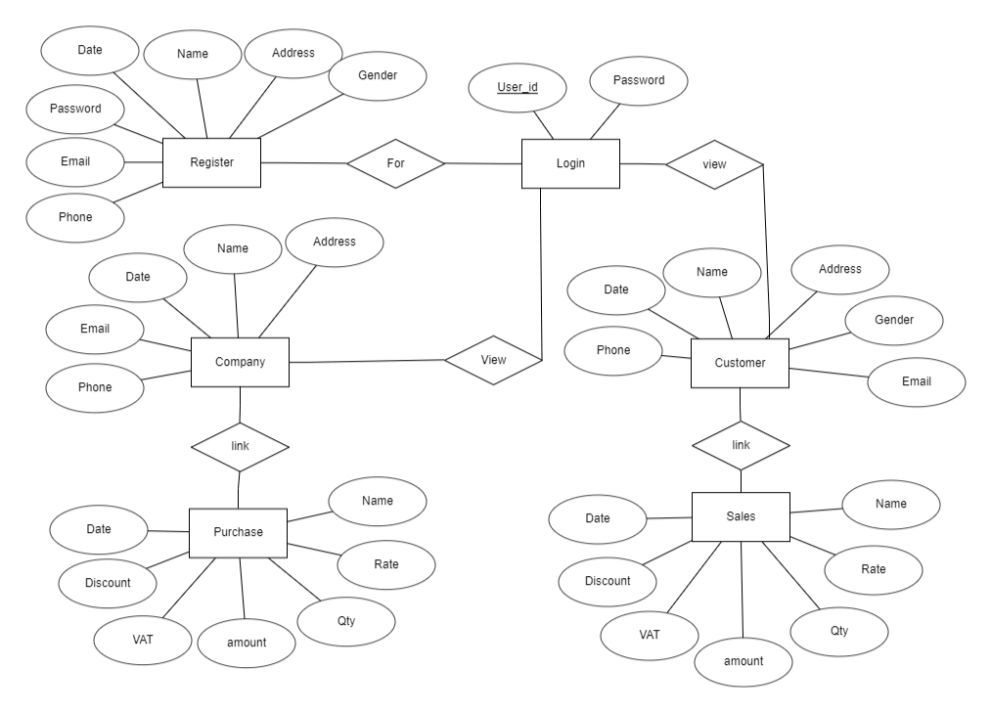

**Figure 2.2.1: E-R diagram**

### 2.2.2 Relational Database Tables

|  |  |  |  |
| --- | --- | --- | --- |
| **S.No.** | **Field name** | **Type** | **Description** |
| 1. | Uid | Number | Store id of user |
| 2. | Date | Date | Store date of first register |
| 3. | Name | Text | Store name of user |
| 4. | Address | Text | Store address of user |
| 5. | Phone number | Number | Store phone number of user |
| 6. | Gender | Text | Store gender of user |
| 5. | Email | Text | Store email of user |
| 6. | Password | Text | Store the password |

**Table 2.2.2.1: Users Table**

|  |  |  |  |
| --- | --- | --- | --- |
| **S.No** | **Field Name** | **Type** | **Description** |
| 1. | Id | Number | Store id of company |
| 2. | Date | Date | Store date of first register |
| 3. | Name | Text | Store name of company |
| 4. | Address | Text | Store address of company |
| 5. | Phone number | Number | Store phone number of company |
| 6. | Description | Text | Store description of company |
| 7. | Email | Text | Store email of company |
| 8. | Uid | Number | Store the id of user |

**Table 2.2.2.2: Company Table**

|  |  |  |  |
| --- | --- | --- | --- |
| **S.No** | **Field Name** | **Type** | **Description** |
| 1. | Cid | Number | Store id of customer |
| 2. | Date | Date | Store date of first register |
| 3. | Name | Text | Store name of customer |
| 4. | Address | Text | Store address of customer |
| 5. | Phone number | Number | Store phone number of customer |
| 6. | Gender | Text | Store gender of customer |
| 7. | Email | Text | Store email of customer |
| 8. | Uid | Number | Store the id of user |

**Table 2.2.2.3: Customer Table**

|  |  |  |  |
| --- | --- | --- | --- |
| **S.No.** | **Field name** | **Type** | **Description** |
| 1. | Pid | Number | Store id of product |
| 2. | Name | Text | Store name of product |
| 3. | Date | Date | Store date of purchase |
| 4. | Description | Text | Store description of product |
| 5. | Rate | Number | Store total amount of particular route |
| 6. | QTY | Number | Store number of days |
| 7. | Amount | Number | Store number of people |
| 8. | VAT | Number | Store vat of product |
| 9. | Discount | Number | Store discount of product |
| 10. | Total_amount | Number | Store total amount of product |
| 11. | Id | Number | Store id of company |

**Table 2.2.2.4: Purchase Table**

|  |  |  |  |
| --- | --- | --- | --- |
| **S.No.** | **Field name** | **Type** | **Description** |
| 1. | Sno | Number | Store sno. of product |
| 2. | Name | Text | Store name of product |
| 3. | Date | Date | Store date of sales |
| 4. | Description | Text | Store description of product |
| 5. | Rate | Number | Store total amount of particular route |
| 6. | QTY | Number | Store number of days |
| 7. | Amount | Number | Store number of people |
| 8. | VAT | Number | Store vat of product |
| 9. | Discount | Number | Store discount of product |
| 10. | Total_amount | Number | Store total amount of product |
| 11. | Cid | Number | Store id of customer |

**Table 2.2.2.5: Sales Table**

# CHAPTER 3

# DEVELOPMENT AND TESTING

## 3.1 Development

### 3.1.1 Login Form

Login form is developed for the authorized user to do the further process. The unauthorized user are not allowed for further processes.

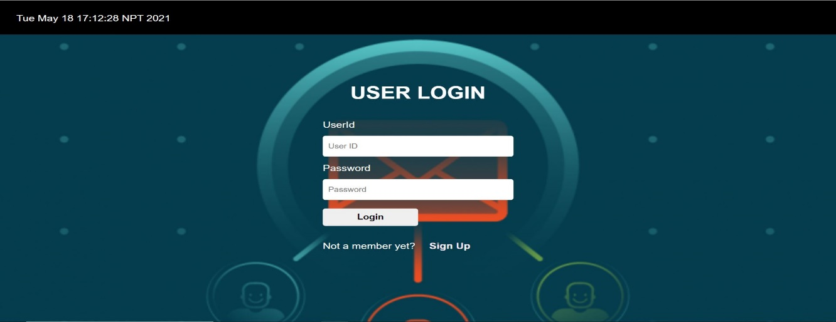

**Figure 3.1.1: Login Page**

### 3.1.2 Registration Form

Registration form is for those people who want the access to our system. The user should register to get authorized for further process.

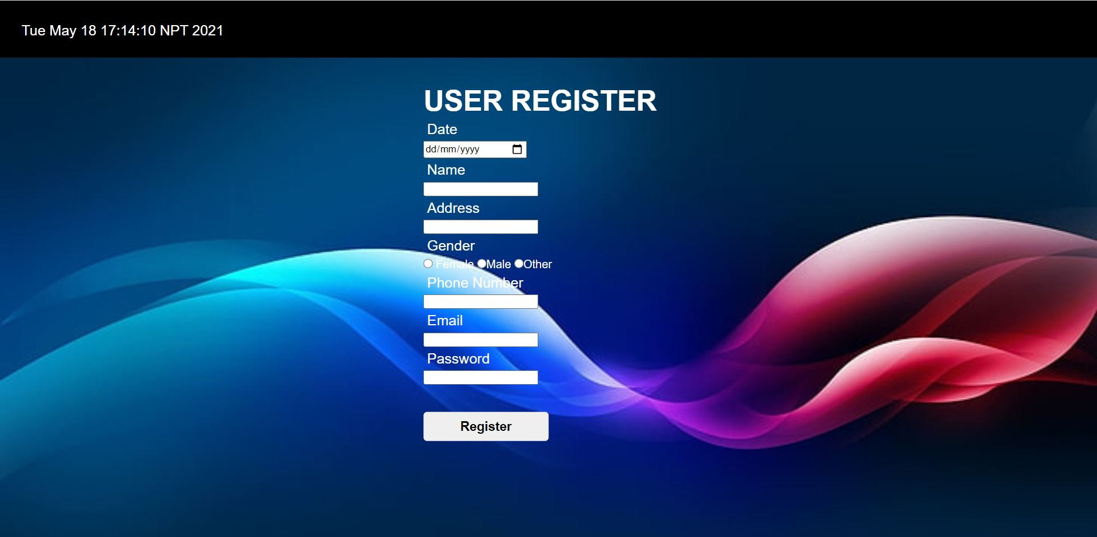

**Figure 3.1.2: Registration Page**

### 3.1.3 Company Register Page

Company registration form is to register new company

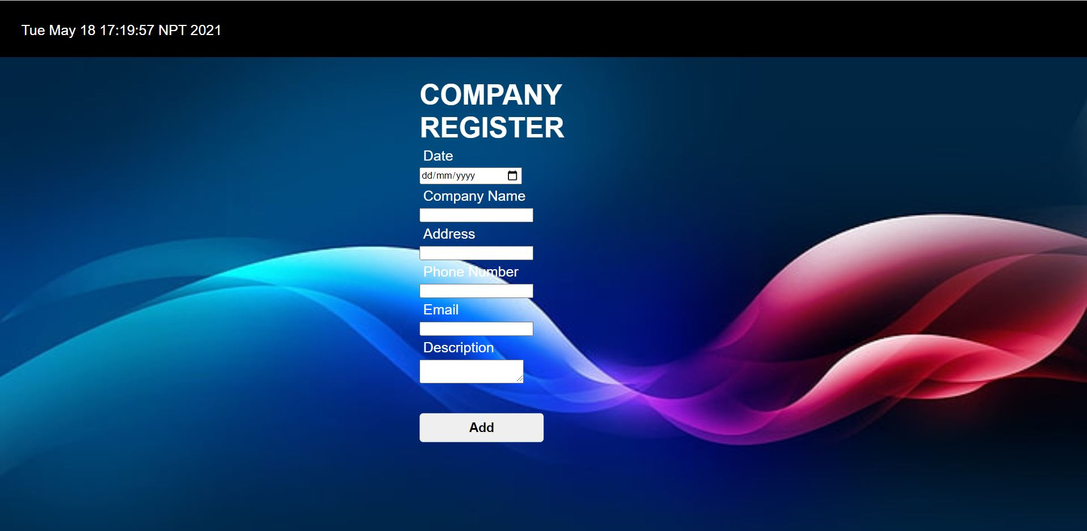

**Figure 3.1.3: Company Registration Form**

### 3.1.4 Customer Register Page

Customer registration form is to register new customer.

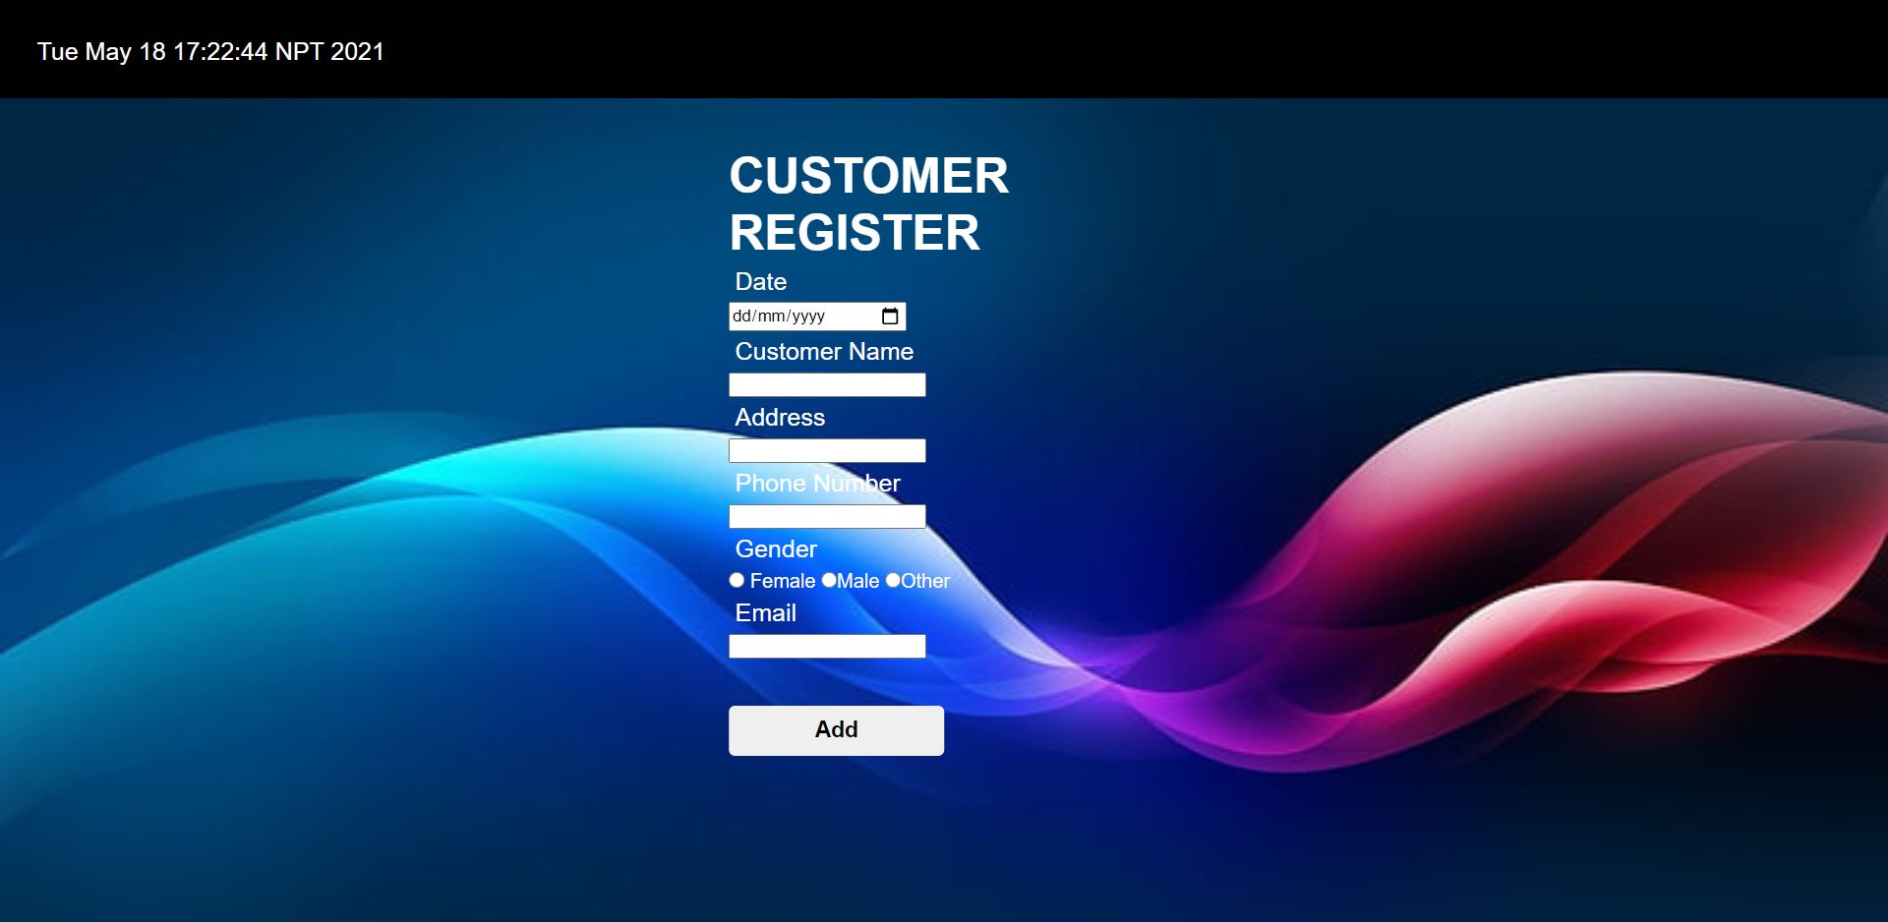

**Figure 3.1.4: Customer Registration Form**

## 3.2 Testing the System

Testing is an improvement phase. This phase involves some testing of developed system using different form of data.

### 3.2.1 Test for User Login

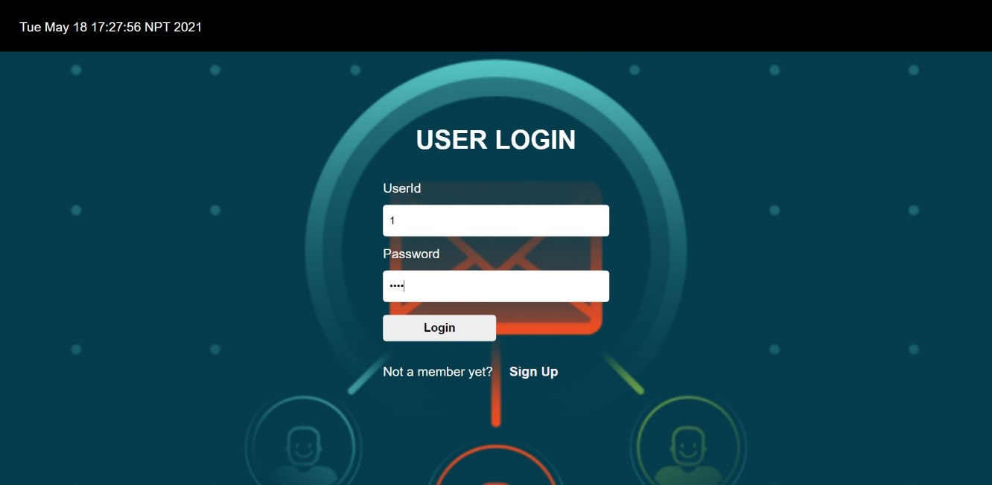

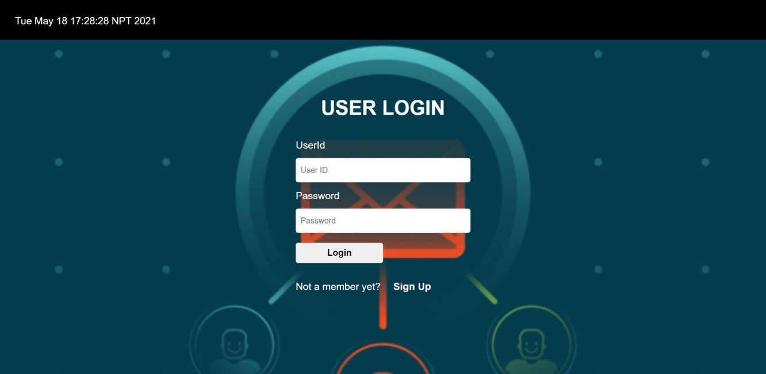

**Figure 3.2.1.1: Test for Invalid Login Data**

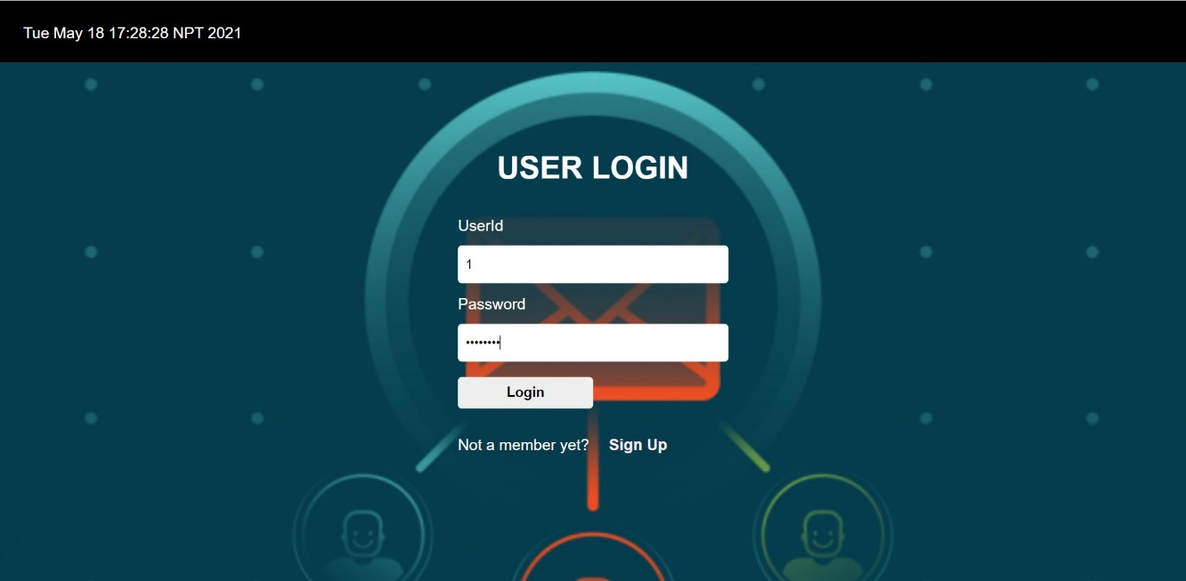

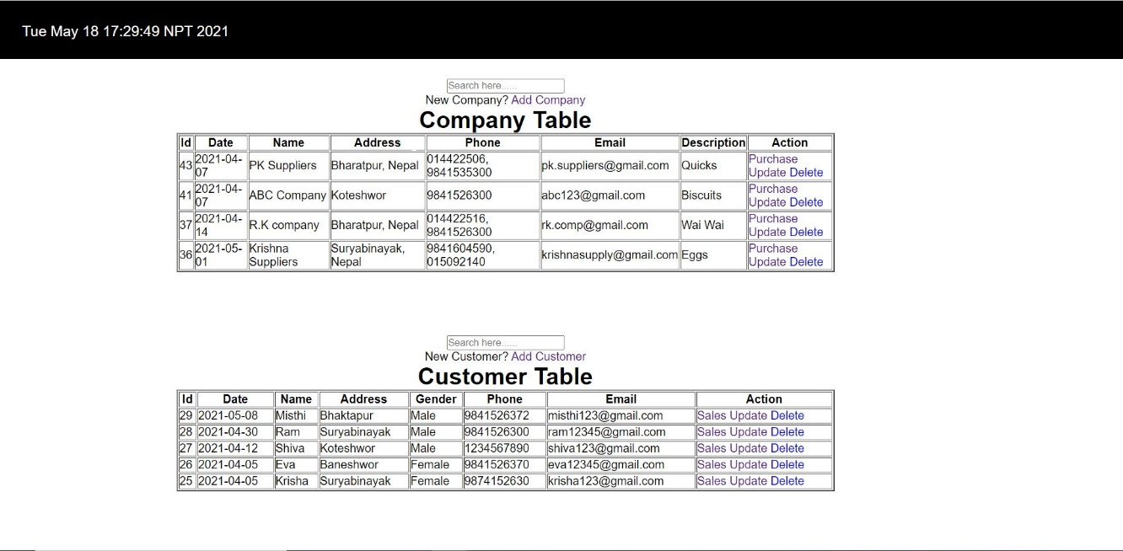

**Figure 3.2.1.2: Test for Valid Login Data**

### 3.2.2 Search Company Detail

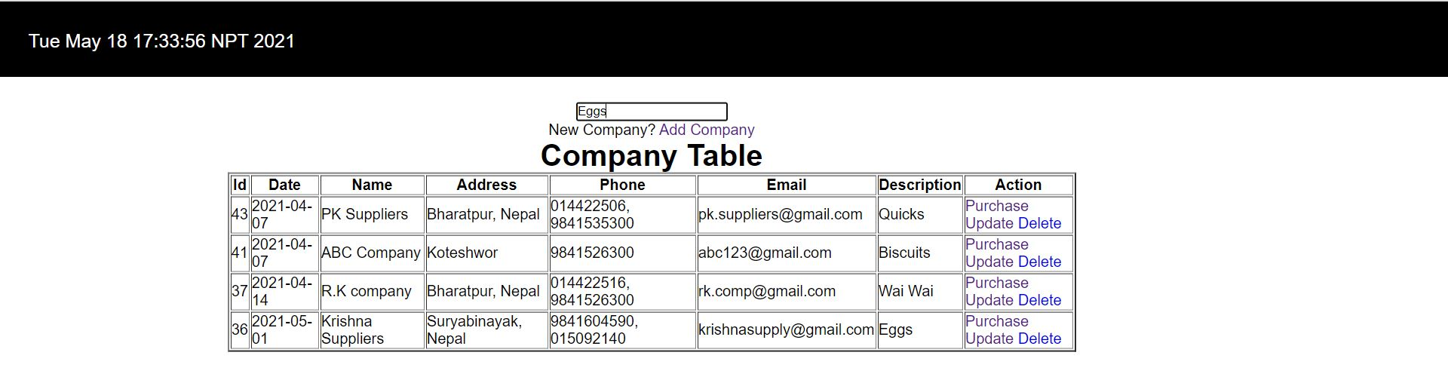

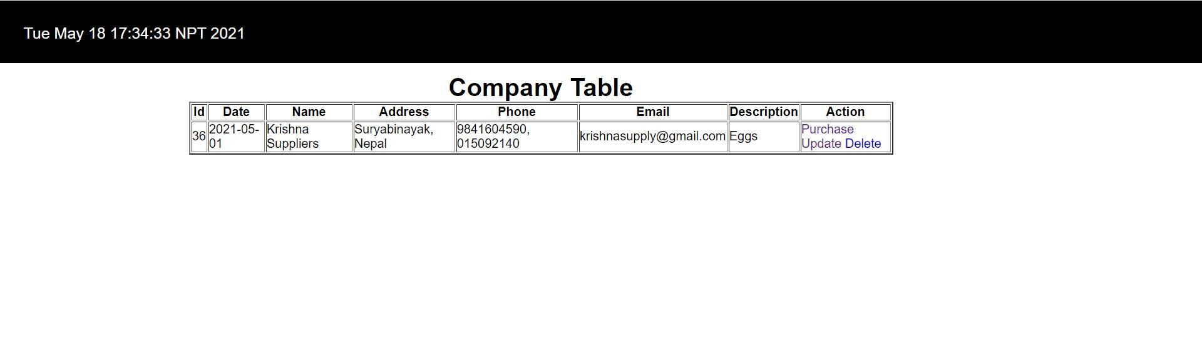

**Figure 3.2.2: Search Detail of Company**

### 3.2.3 Search Customer Detail

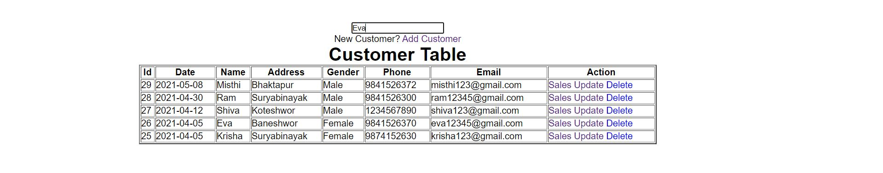

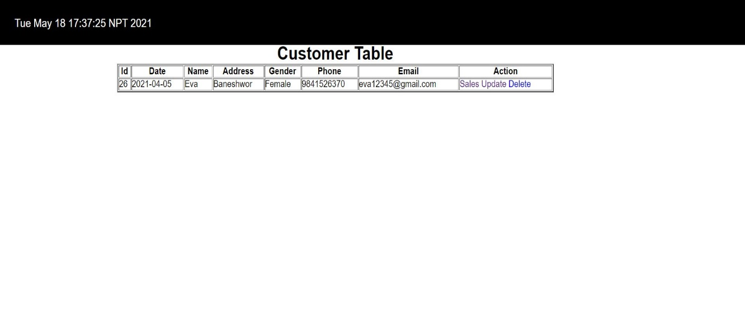

**Figure 3.2.3: Search Detail of Customer**

### 3.2.4 Update of Product in purchase

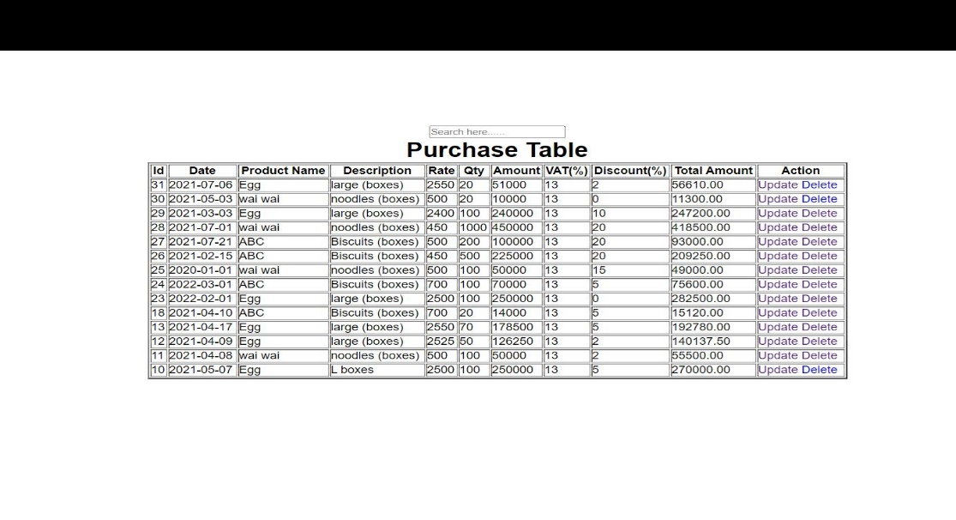

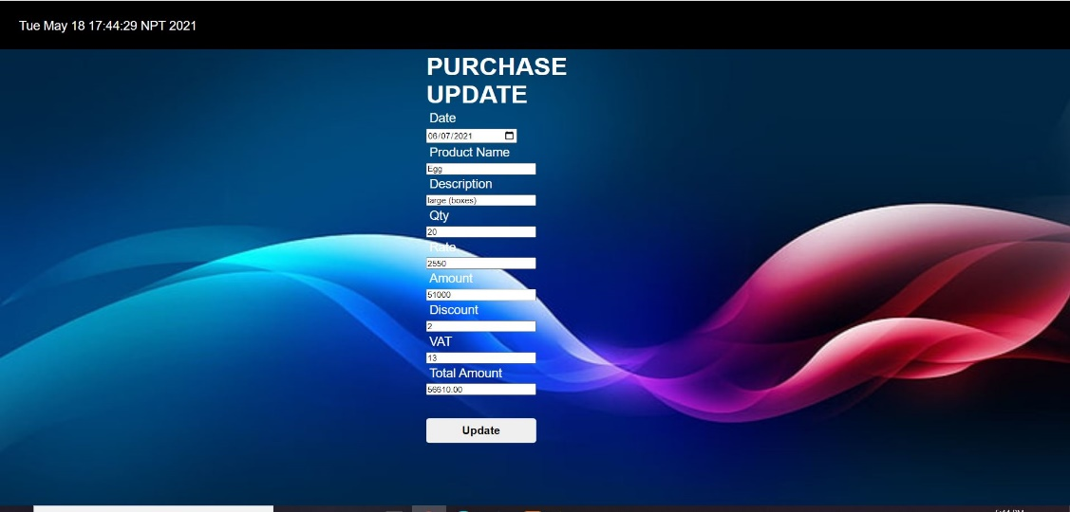

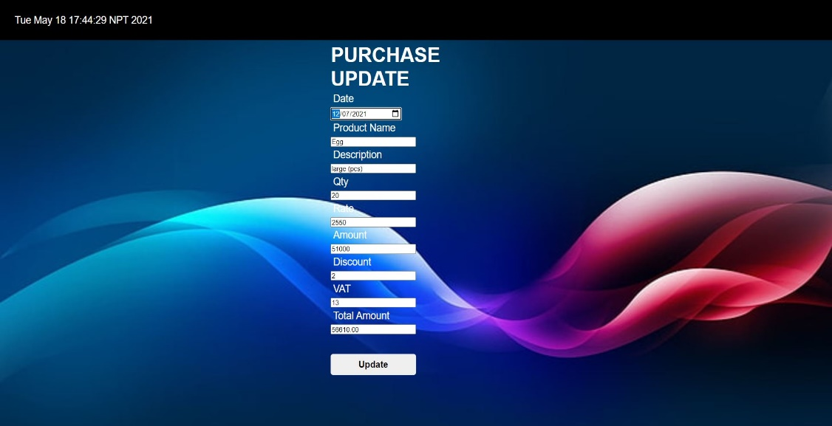

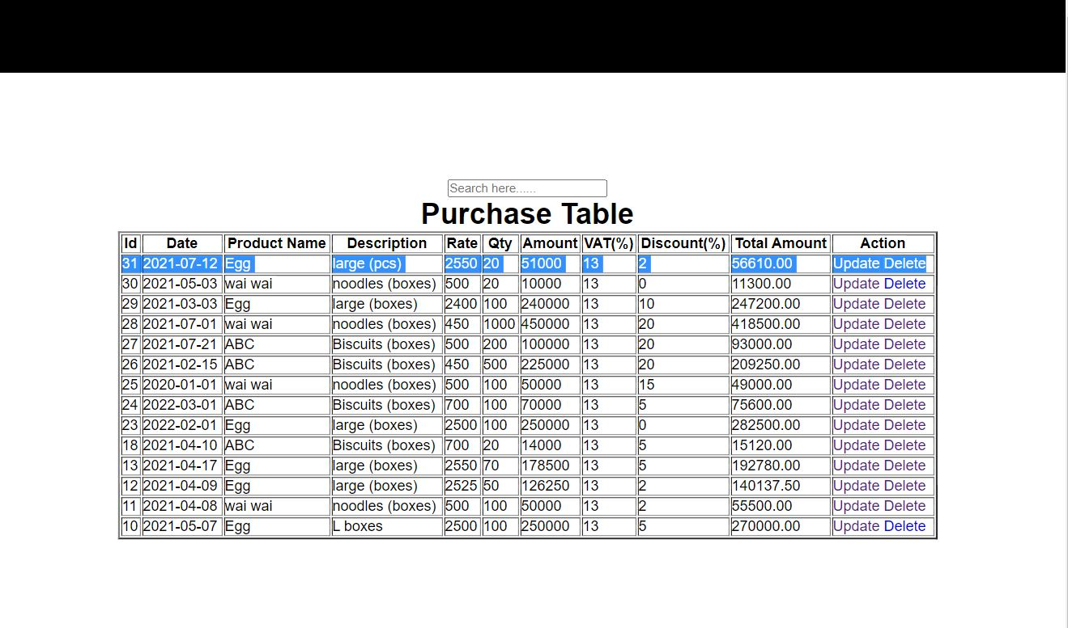

**Figure 3.2.4: Update of Product**

# CHAPTER 4

# CONCLUSION

The developed system is very easy to use and time saving. It maintains the records of various purchase and sales transaction. This system for storing and maintaining the data in digital form.